The Bat Can Bat: A Book of True Homonyms
By Gene Barretta
Compiled by Bitsy Galaska, Librarian Robeson Elementary Center

Common Core State Standards-English Language Arts-Literacy, Reading Foundational, First Grade
CCSS.ELA-Literacy.RF.1.2a Distinguish long from short vowel sounds in spoken single-syllable words.
CCSS.ELA-Literacy.RF.1.3b Decode regularly spelled one-syllable words
CCSS.ELA-Literacy.RF.1.3e Decode two-syllable words following basic patterns by breaking the words into syllables.
CCSS.ELA-Literacy.RF.1.4c Use context to confirm or self-correct word recognition and understanding, rereading as necessary.
CCSS.ELA-Literacy.RF.1.4a Read grade-level text with purpose and understanding.

Common Core State Standards-English Language Arts-Literacy, Speaking Listening, First Grade
CCSS.ELA-Literacy.SL.1.5 Add drawings or other visual displays to descriptions when appropriate to clarify ideas, thoughts, and feelings.

Focus
Students listen to story using homonyms and make text-to-text connections by matching selected homonyms.

Activation
Introduce author Gene Barretta to students and share information about him from his website www.genebarretta.com. Explain we will be reading a book written by Gene that tells us about words that are spelled the same, sound the same, but have different meanings.

Pre Reading Conversation:
- Have you ever noticed words that sound the same, are spelled the same, but different meanings?
- They have a special name, do you have any idea what that name could be?
- Can you give an example of a homonym?

Post Reading Conversation:
- After reading the book, do you know any homonyms?
- Did the pictures in the book help you understand homonym? How?
- Did you notice that words could sound the same, are spelled the same, but mean something different?

Lesson Ideas:
Matching Game-
- Prepare cards with written homonyms, enough for one per student
- Create (teacher or together as a class) sentences using examples from the book that use the homonyms correctly
- Read sentences, have students stand up when their homonym is read and reinforce by having students explain the meaning of a pair of homonyms.

Illustrate Homophones-
- Pair students, give each pair a set of homonyms, written on a card.
- Each student must illustrate their homonyms, example:
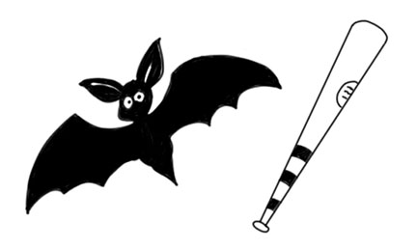

- Students share their illustrations and classmates must figure out the homonym.

