The Bass Plays the Bass and Other Homographs
By Gene Barretta
Compiled by Bitsy Galaska, Librarian Robeson Elementary Center

Common Core State Standards-English Language Arts-Literacy, Reading Foundational, First
Grade
CCSS.ELA-Literacy.RF.1.2a Distinguish long from short vowel sounds in spoken single-syllable
words.
CCSS.ELA-Literacy.RF.1.3b Decode regularly spelled one-syllable words
CCSS.ELA-Literacy.RF.1.3e Decode two-syllable words following basic patterns by breaking the
words into syllables.
CCSS.ELA-Literacy.RF.1.4c Use context to confirm or self-correct word recognition and
understanding, rereading as necessary.
CCSS.ELA-Literacy.RF.1.4a Read grade-level text with purpose and understanding.
Common Core State Standards-English Language Arts-Literacy, Speaking Listening, First Grade
CCSS.ELA-Literacy.SL.1.5 Add drawings or other visual displays to descriptions when appropriate
to clarify ideas, thoughts, and feelings.

Focus
Students listen to story using homographs and make text-to-text connections by matching
selected homographs.

Activation
Introduce author Gene Barretta to students and share information about him from his website
www.genebarretta.com. Explain we will be reading a book written by Gene that tells us about
words that are spelled the same, but have different meanings.

Pre Reading Conversation:
• Have you ever noticed words that are spelled the same, but are pronounced differently
have different meanings?
• They have a special name, do you have any idea what that name could be?
• Can you give an example of a homograph?

Post Reading Conversation:
• After reading the book, do you know any homographs?
• Did the pictures in the book help you understand homographs? How?
• Did you notice that just by saying the word syllables differently, it changes the meaning
of the word?
• Do you know any homographs?

Vocabulary
Homograph
Minute (tiny)
Rebel (both meanings)
Entrance (both meanings)
Console (both meanings)
Polish (culture)

Lesson Ideas:
Matching Game-
• Prepare cards with written homographs, enough for one per student
• Create (teacher or together as a class) sentences using examples from the book that use the homographs correctly
• Read sentences, have students stand up when their homograph is read and reinforce by
having students pronounce their homograph both ways
Alternate Matching Game-
• Prepare separate cards with a homograph sentence on each one using examples from
the book
• Turn cards with sentence face down on table
• Students play a match game by selecting two cards, player keeps the cards if the
homographs match
Illustrate Homographs-
• Pair students, give each pair a homograph pair written on a card.
• Each student must illustrate their homographs, example:

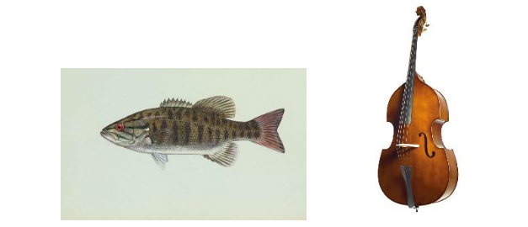
• Students share their illustrations and classmates must figure out the homograph.

Extra:
Share a video about The Bass Plays the Bass (formerly titled Zoola Palooza) found on Youtube:
http://www.youtube.com/watch?v=YFwOU8Dn1oc
http://www.youtube.com/watch?v=j6l9jRcCzY8

