Lincoln and Kennedy: A Pair to Compare
By Gene Barretta
Lesson by Bitsy Galaska, Librarian Robeson Elementary Center

Common Core State Standards-English Language Arts-Literacy, Reading Informational Text Grade 2, 3 and 4
CCSS.ELA-Literacy.RI.2.1-Ask and answer such questions as who, what, where, when, why, and how to demonstrate understanding of key details in a text.
CCSS.ELA-Literacy.RI.3.7 Use information gained from illustrations (e.g., maps, photographs) and the words in a text to demonstrate understanding of the text (e.g., where, when, why, and how key events occur).
CCSS.ELA-Literacy.RI.3.8 Describe the logical connection between particular sentences and paragraphs in a text (e.g., comparison, cause/effect, first/second/third in a sequence). CCSS.ELA-Literacy.RI.4.1-Refer to details and examples in a text when explaining what the text says explicitly and when drawing inferences from the text.
CCSS.ELA-Literacy.RI.4.2-Determine the main idea of a text and explain how it is supported by key details; summarize the text.
CCSS.ELA-Literacy.RI.4.3-Explain events, procedures, ideas, or concepts in a historical, scientific, or technical text, including what happened and why, based on specific information in the text.
CCSS.ELA-Literacy.RI.4.3-Explain events, procedures, ideas, or concepts in a historical, scientific, or technical text, including what happened and why, based on specific information in the text.

Focus
Students listen to story and build knowledge of presidents through discussion and research.

Activation
Introduce Gene Barretta as author and illustrator of book, students can research author further by visiting www.genebarretta.com . Explain the concept of book and whom the book is about.

Pre-Reading Conversation
- Who is the President of the United States?
- What do you think the President does?
- Do you think this is a difficult job?
- (Show book and record answers) What do we know about the presidents on the cover?

Lesson Ideas:
- Second Grade, compare as whole class using Venn diagram. After reading the story, have discussion and record facts within the Venn diagram in appropriate place.

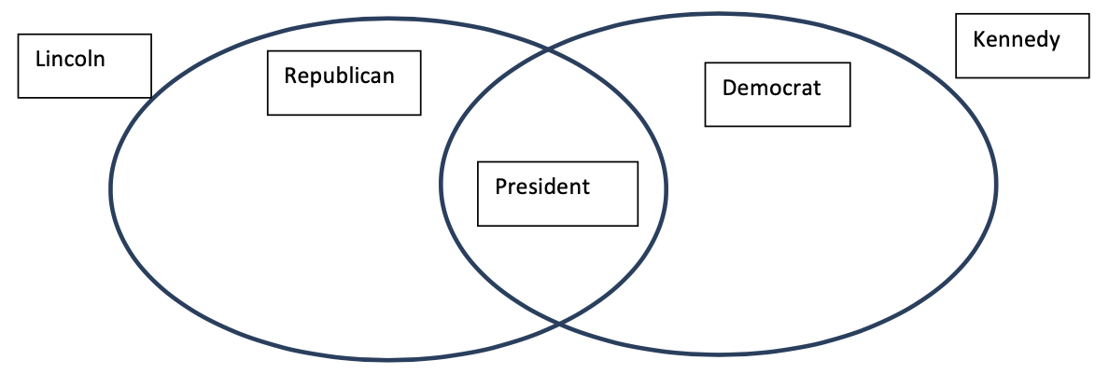

2. Third grade-Celebrate Presidents’ Day by allowing students to select two different presidents to research. Provide print and online materials for students to investigate. Solid research websites include: https://www.whitehouse.gov/1600/Presidents http://www.americaslibrary.gov/aa/presidents.php
Students research and compare the two presidents they have selected. Ask students to find information that is similar/different, have students create a T-chart to record their answers. Note: There may not be as many similarities as Lincoln and Kennedy; however, students will gain knowledge and research skills trying to find related items. Model a T-Chart with the whole class using Lincoln and Kennedy; a Pair to Compare. For differentiation; have students work in pairs to examine an assigned page(s) from the book and identify similar/different items (clothing, transportation, buildings, etc.)

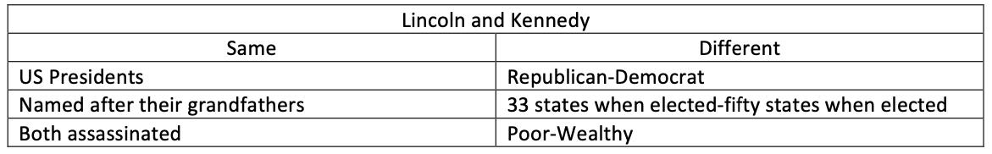

- Modify for any grade- On page 40 of Gene’s book, Lincoln and Kennedy; a Pair to Compare, is a glossary. Examine the glossary as a whole class and discuss this non-fiction text feature. Have students select a president they want to research. Students create a glossary of terms for their president based on facts found during research. Continue non-fiction text feature exploration with the sources cited list. Students will record their sources used in creating their glossary.
- Fourth grade-After reading the story, have students research further on what was each president’s biggest challenge while in office.
Define the word legacy with students; what was the legacy left behind by each president. Have students work in pairs to discuss and compare their research findings and present to the whole class.
The road map to becoming president; how does a person become the president of the United States? Build a unit around the election process, use the book Lincoln and Kennedy; a Pair to Compare as a starting point. Emphasize the campaign struggles and successes in the book. Excellent resource on how the process works can be found at Kids.gov https://kids.usa.gov/president/index.shtml

