Dear Deer: A Book of Homophones
By Gene Barretta
Compiled by Bitsy Galaska, Librarian Robeson Elementary Center

Common Core State Standards-English Language Arts-Literacy, Reading Foundational, First Grade
CCSS.ELA-Literacy.RF.1.2a Distinguish long from short vowel sounds in spoken single-syllable words.
CCSS.ELA-Literacy.RF.1.3b Decode regularly spelled one-syllable words
CCSS.ELA-Literacy.RF.1.3e Decode two-syllable words following basic patterns by breaking the words into syllables.
CCSS.ELA-Literacy.RF.1.4c Use context to confirm or self-correct word recognition and understanding, rereading as necessary.
CCSS.ELA-Literacy.RF.1.4a Read grade-level text with purpose and understanding.

Common Core State Standards-English Language Arts-Literacy, Speaking Listening, First Grade
CCSS.ELA-Literacy.SL.1.5 Add drawings or other visual displays to descriptions when appropriate to clarify ideas, thoughts, and feelings.

Focus
Students listen to story using homophones and make text-to-text connections by matching selected homographs.

Activation
Introduce author Gene Barretta to students and share information about him from his website www.genebarretta.com. Explain we will be reading a book written by Gene that tells us about words that are spelled the same, but have different meanings.

Pre Reading Conversation:
- Have you ever noticed words that sound the same, but are spelled differently and have different meanings?
- They have a special name, do you have any idea what that name could be?
- Can you give an example of a homophone?

Post Reading Conversation:
- After reading the book, do you know any homophones?
- Did the pictures in the book help you understand homophones? How?
- Did you notice that words could sound the same but look so different?
- Do you know any homophones?

Vocabulary
Homophone
Dear - Deer (both meanings & spellings)
Aunt - Ant (both meanings & spellings)
Hear - Here (both meanings & spellings)
Moose - Mouse (both meanings & spellings)
Ate - Eight (both meanings & spellings)
You - Ewe (both meanings & spellings)
Daze - Days (both meanings & spellings)
Him - Hymn (both meanings & spellings)
Hoarse - Horse (both meanings & spellings)
Feat - Feet (both meanings & spellings)
Tale - Tail (both meanings & spellings)
Doe - Dough (both meanings & spellings)
Toad - Towed – (both meanings & spellings)
Kneaded – Needed (both meanings & spellings)
See - Sea (both meanings & spellings)
Whale - Wail (both meanings & spellings)
Allowed - Aloud (both meanings & spellings)
Bare - Bear (both meanings & spellings)
Paws - Pause (both meanings & spellings)
Hey - Hay (both meanings & spellings)
Threw - Through (both meanings & spellings)
Red – Read (both meanings & spellings)
Blew - Blue (both meanings & spellings)
Choose - Chews (both meanings & spellings)
Herd - Heard (both meanings & spellings)
Mood - Mooed (both meanings & spellings)
Flew - Flu (both meanings & spellings)
Bee - Be (both meanings & spellings)
Flee - Flea (both meanings & spellings)
News - Gnus (both meanings & spellings)
Hare - Hair (both meanings & spellings)
No - Know (both meanings & spellings)

Lesson Ideas:
Matching Game-
- Prepare cards with written homophones, enough for one per student
- Create (teacher or together as a class) sentences using examples from the book that use the homophones correctly
- Read sentences, have students stand up when their homophone is read and reinforce by having students spell their homophone both ways

Alternate Matching Game-
- Prepare separate cards with a homophone sentence on each one using examples from the book
- Turn cards with sentence face down on table
- Students play a match game by selecting two cards, player keeps the cards if the homophones match
Illustrate Homophones-
- Pair students, give each pair a set of homophones, written on a card.
- Each student must illustrate their homophones, example:
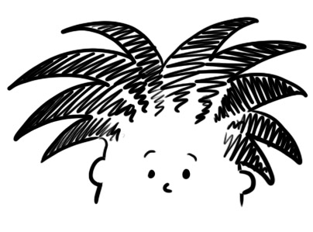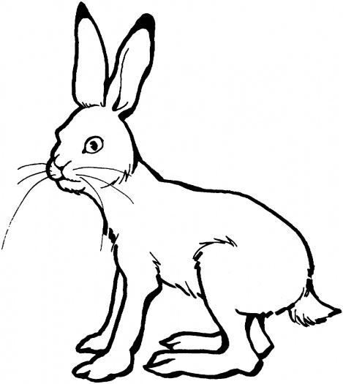
- Students share their illustrations and classmates must figure out the homophone.

